

***in this issue SEPT 2025 >>>***

Issue

You and Your GP

For up to date information on what you can expect from us as your general practice and how you can help us so that you get the best from the NHS, please refer to our website [www.haslingdenmedicalgrouppractice.co.uk](http://www.haslingdenmedicalgrouppractice.co.uk)

and click the document titled ‘You and your GP’

***Health Focus: Mental Health***



Farewell to Dr Fozdar 👋

We’re sad to announce that Dr Fozdar will be leaving our practice after six amazing years with us. His last working day will be Tuesday, 29th October 2025.

Dr Fozdar has been a highly respected and much-loved member of our team. His dedication, warmth, and professionalism have made a lasting impact on both patients and colleagues, and he will be greatly missed by all. Whilst we’re very sad to see him go, we wish him every success in this exciting next chapter.

Thank you Dr Fozdar you have been a credit to the practice and community.

Best wishes, Haslingden Healthcare

The Enhanced Access Service

As the seasons change, it's important to look after your mental well-being. If you're feeling overwhelmed, anxious, or low, you're not alone.  
We offer:

* GP mental health reviews
* Talking therapies
* Self-help resources and referrals

Speak to a GP or visit our **Mental Health Support** page on the website for more info.

* *Dr Fozdar sadly leaving*
* *Mental Health Matters*
* *Urology Awareness*
* *Travel Vaccines*

**Haslingden Health Care NEWS**

* *You and Your GP*
* *Flu/Covid vaccines*
* *New staff!*
* *Stoptober*
* *Menopause Awareness Day*
* *New Prescription Hub*
* *Clinical Trials*

And MORE…

The Enhanced Access Service in Rossendale is held at Rossendale Health Centre (Inside Ilex View Practice) as well as Bacup Health Centre (Inside Irwell Medical Practice)

The service is held at Rossendale Health Centre, 17:00pm – 20:45pm on Tuesdays, Wednesdays, Fridays and Saturdays 9-2pm. The service is held at Bacup Health Centre, 17:00pm – 20:45pm on Mondays and Thursdays. Appointments within this service are both Face to Face and Remote (Telephone/Video Call).

These appointments can be with either a GP, ANP, Practice Nurse or Health Care Assistant. These clinicians have access to your GP Practice record, to enable them to see all results, letters and consultations to enable a continuity of care during your appointment with the Enhanced Access Service.

Web: [**https://eastlancashirealliance.co.uk**](https://eastlancashirealliance.co.uk/)

Facebook: [**https://www.facebook.com/EastLancsAlliance/**](https://www.facebook.com/EastLancsAlliance/)

Email: [**Ela.servicefeedback@nhs.net**](mailto:Ela.servicefeedback@nhs.net)

**THE AUTUMN ISSUE**



Hello, my name is Dr Xue Ning Lee (Ning) and I am excited to have joined the practice as a GP ST3 in my final year of training. I completed MBBS in 2021 and have since worked in both hospital and community setting. I enjoy listening to patients’ stories and believe in working together to provide the best, holistic care.

Hi, I’m Anam Chahat your new First Contact Physiotherapist with over 12 years of experience in musculoskeletal physiotherapy. I’m fully registered with both the HCPC and the Chartered Society of Physiotherapy. I’ve completed the FCP Roadmap to Practice through Essex University and hold additional qualifications in injection therapy. I see patients with MSK concerns without the need for a GP referral. I’m trained to assess, diagnose, and support a wide range of musculoskeletal conditions, creating tailored rehab plans, offering lifestyle advice, arranging further investigations, or referring on to specialist services. My focus is always on helping patients get the right care as early as possible, to help manage symptoms effectively 😊

*NEW STAFF!*



Stoptober is back! Join thousands of other smokers committing to quit this October. Even if it’s your first time or you’ve tried before, now is the perfect time to quit smoking. Make it to 28 days smoke-free and you’re 5 times more likely to quit for good!



STOPTOBER

World Menopause Awarennes day – 18th Oct

Raising awareness for women who are feeling lost and going through Menopause and also need support.

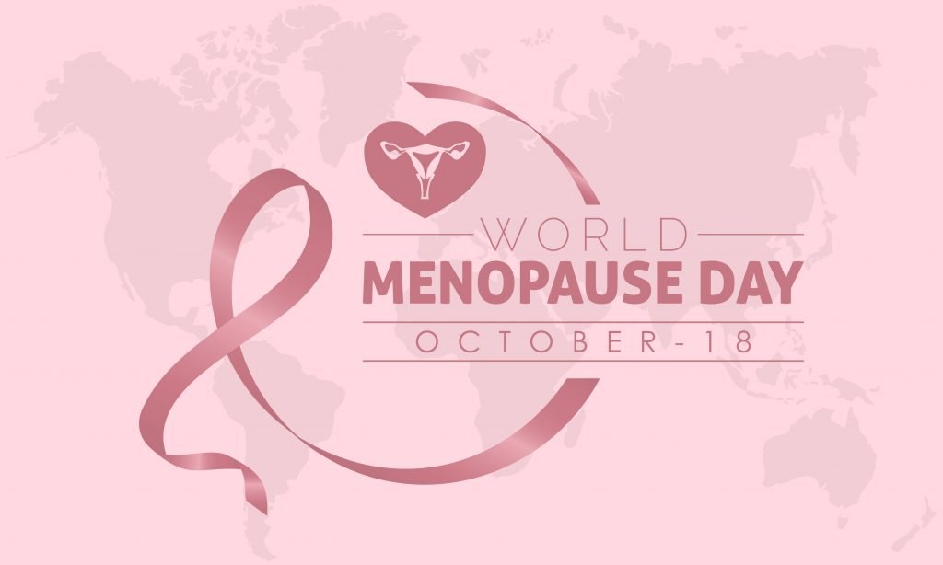

Travel Vaccines

We are now offering NHS travel vaccines at the practice. To find out further information and to see if you are eligible, please contact reception and request a travel vaccine questionnaire form.

A questionnaire will be sent across to you to complete and return to us. A nurse will then review this form and an appointment will be made dependent on the review.

**Please contact the practice at least 12 weeks in advance before your travel date to start this process**

Haslingden Healthcare are now offering a service for all patients to send directly Non-Medical Queries and Admin Requests using the link below, which includes sicknotes, letters and updates regarding test results.

You can access this service using the link below.

[**https://florey.accurx.com/p/P81099**](https://florey.accurx.com/p/P81099)

**You can also access this service using the NHS App.**

**For further information please speak to the reception team.**

*Patient Non Medical Queries -*

***ask the experts >>>***

COVID AND FLU VACCINES

We are now starting our covid and flu boosters. Please note that you will receive a text message inviting you to book an appointment if you are eligible.

We cannot offer the covid vaccine on its own. If you would like just the covid booster, please contact the pharmacy for this.

There will be additional clinics held every Saturday through Oct/Nov.

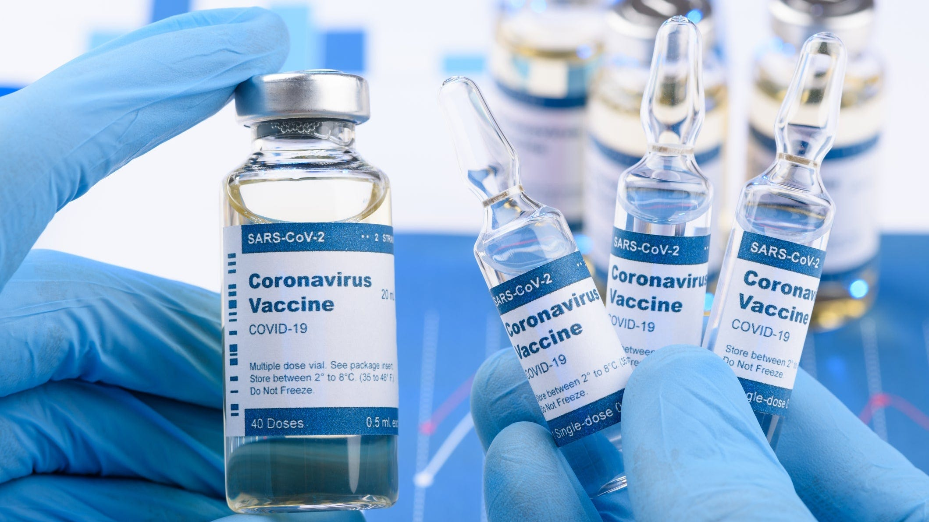

**Home Blood Pressure Monitoring Deposits**

Our practice has now implemented a new deposit scheme for loaning home blood pressure monitoring machines.

We will now require a £10 deposit before loaning you a machine - this will be returned to you when you bring the machine back to reception.

*Please note if you do not bring the home monitoring machine back to reception within 2 weeks this deposit will be non-refundable.*

**Prebooking appointments through the MyGP App**

Please note that we now have limited appointments that are available to book the night before on the MyGP App. These appointments are released at 6.30pm Sunday-Thursday.

Our new prescription hub is now live. If you are **over 70** or **clinically vulnerable,** please contact 01706 335390 and select option 2 to order your prescription.

For anyone that does **not** meet the above criteria you can either email lscicb-el.macscripts@nhs.net or [mackenzie.reception@nhs.net](mailto:mackenzie.reception@nhs.net) to order. Alternatively, you can order through online patient access or fill in a slip at Reception.

SMOKING CESSATION

Smoking can lead to strokes, cancer, heart and lung disease. We strongly advise quitting. The best way to stop is with a combination of medication and specialist support.

*You can try the NHS Quit Smoking app, or for more information visit:* [*www.nhs.uk/smokefree*](http://www.nhs.uk/smokefree)



*NEW PRESCRIPTION HUB*

***Urology Awareness Month -***

[**Urology Awareness Month** is observed every **September** to raise awareness about urological health and diseases. Throughout the month, various activities are organized, including webinars, health sessions, and fundraising events to highlight urology diseases and promote health awareness](https://www.bing.com/ck/a?!&&p=ee14ddf99746a1cb9fecbda02c9c0a45a74e1164dd05e5314309798f91159d22JmltdHM9MTc1ODA2NzIwMA&ptn=3&ver=2&hsh=4&fclid=0a08171a-1d1c-6738-1b1a-010e1c8b6639&psq=what+is+urology+awareness+month&u=a1aHR0cHM6Ly93d3cudGhldXJvbG9neWZvdW5kYXRpb24ub3JnL2dldC1pbnZvbHZlZC9ldmVudHMvdXJvbG9neWF3YXJlbmVzc21vbnRoLw&ntb=1)

**It is officially Autumn!** Darker nights and colder evenings are here.

Please make sure to book in for your autumn flu and covid booster if you are due these.

**Thank you for being part of the Haslingden Healthcare community. Wishing you a healthy and safe start to Autumn.**

Warm regards,  
**The Oakwood Medical Centre Team**



***The colder days are upon us…***

Haslingden Healthcare is now participating in clinical trials.

Some patients may be contacted and receive a message alert about these clinical trials requesting you to join in.

If you are interested in the clinical trial then follow the instructions in the message you receive, please do not contact reception about this.

**No personal or medical information will be released without your consent.**



Clinical Trials

**Stay up to date:**

Facebook – Haslingden Healthcare Ltd

Email – [mackenzie.reception@nhs.net](mailto:mackenzie.reception@nhs.net)

Number – 01706 335390

Would you like to join our PATIENT PARTICIPATION GROUP?

We are looking for enthusiastic, dedicated patients for their views on upcoming changes and to help shape the delivery of services. Some questions that could be raised are below…

* How long do I have to wait for a GP appointment?
* How can I access mental health services?
* I just want to check my blood test results, can I do this without speaking to a healthcare professional?
* Why do the receptionists need to know what my appointment is for?

For more information please contact reception:

01706 335590 or mackenzie.reception@nhs.net

*Finding An Agent That’s Right For You*