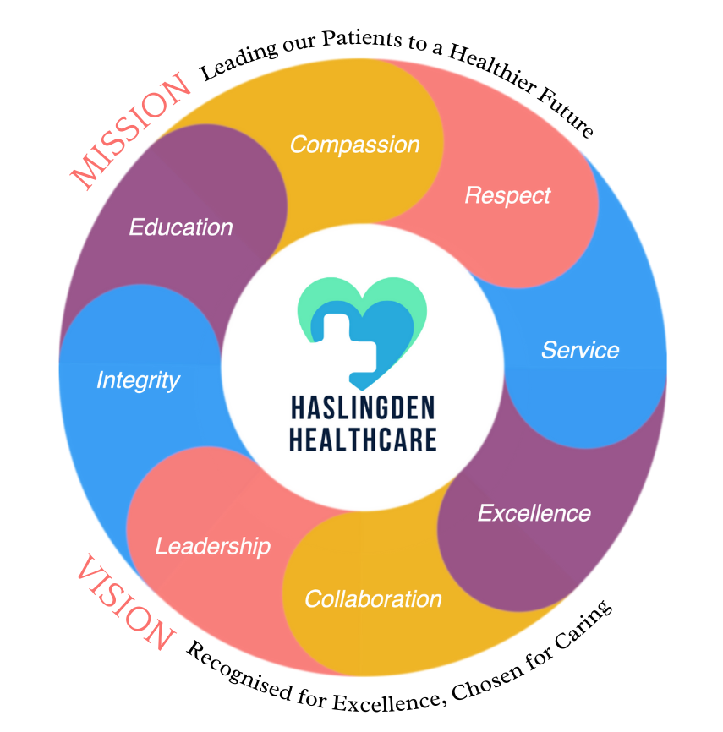

***in this issue SEPTEMBER 2024 >>>***

Issue

The Enhanced Access Service

The Enhanced Access Service in Rossendale is held at Rossendale Health Centre (Inside Ilex View Practice) as well as Bacup Health Centre (Inside Irwell Medical Practice)

The service is held at Rossendale Health Centre, 17:00pm – 20:45pm on Tuesdays, Wednesdays, Fridays and Saturdays 9-2pm. The service is held at Bacup Health Centre, 17:00pm – 20:45pm on Mondays and Thursdays. Appointments within this service are both Face to Face and Remote (Telephone/Video Call).

These appointments can be with either a GP, ANP, Practice Nurse or Health Care Assistant. These clinicians have access to your GP Practice record, to enable them to see all results, letters and consultations to enable a continuity of care during your appointment with the Enhanced Access Service.

Web: [**https://eastlancashirealliance.co.uk**](https://eastlancashirealliance.co.uk/)

Facebook: [**https://www.facebook.com/EastLancsAlliance/**](https://www.facebook.com/EastLancsAlliance/)

Email: [**Ela.servicefeedback@nhs.net**](mailto:Ela.servicefeedback@nhs.net)

FLU/ COVID VACCINES We are now offering flu and covid jabs to those who are eligible. You will receive a text requesting for you to book in. We have appointments available during the week and on Saturdays throughout Oct and Nov.

RSV/SHINGLES/WHOOPING COUGH VACCINES RSV vaccines are now available for those aged between 75-79. Shingles vaccines are now available for **some** patients aged between 70 -80. Whooping cough vaccines are available for anyone who is pregnant. Please note you will receive a text asking you to book in. You can also ring reception to check if you are eligible.



* *GetUBetter MSK app*
* *RSV/Shingles/Whooping cough vaccines*
* *Baby loss awareness week*

***Urology Awareness Month – September***

**Breast Cancer Awareness Month – October**

**If secondary breast cancer affects you or the ones you love, our research could help buy more time.**

**WEAR IT PINK! 18th OCT 24. Raise money. Help make life-changing breast cancer research happen.**



**Raises awareness of urology diseases including bladder, kidney, prostate and male reproductive cancers and non-malignant conditions. It is an opportunity to bring together the urology community –patients and their families.**

**We highlight facts about urology health alongside launching new videos and resources.**

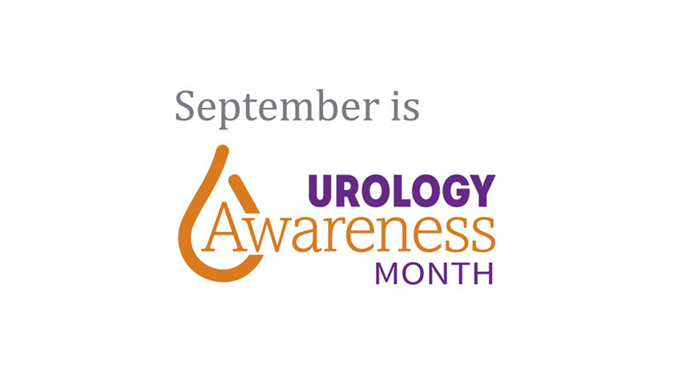

**Haslingden Health Care NEWS**

* *Flu & Covid vaccines*
* *Travel vaccines*
* *Movember*
* *Trans awareness week*
* *Patient participation group*
* *Remembrance Sunday*
* *New Staff*

And MORE…

**THE AUTUMN ISSUE**



**Mental Health Practitioner – Abi**

I'm Abi, a Mental Health Practitioner that works across 6 surgeries in the Rossendale West area. I am a qualified mental health nurse with 11 years of experience of working with people with mental health problems. I've worked in a variety of different settings including in-patient mental health wards, crisis assessment units, early intervention with psychosis, and more recently A&E completing MH crisis assessments. In this current role, I can see anyone who is struggling with their mental health, assess, give advice, signpost to relevant services, review medication, and provide brief psychological interventions.

**FY2 Doctor – Naoise**

My name is Naoise, I'm one of the FY2 doctors on my GP rotation. I'll be here for 4 months. My main role is seeing patients and trying to help manage the problems that they come in with. I'm also learning new skills from all the other healthcare workers and members of staff here at the practice.

*Staff News!*



Give anyone touched by pregnancy and baby loss a safe and supportive space to share their experiences and feel that they are not alone.

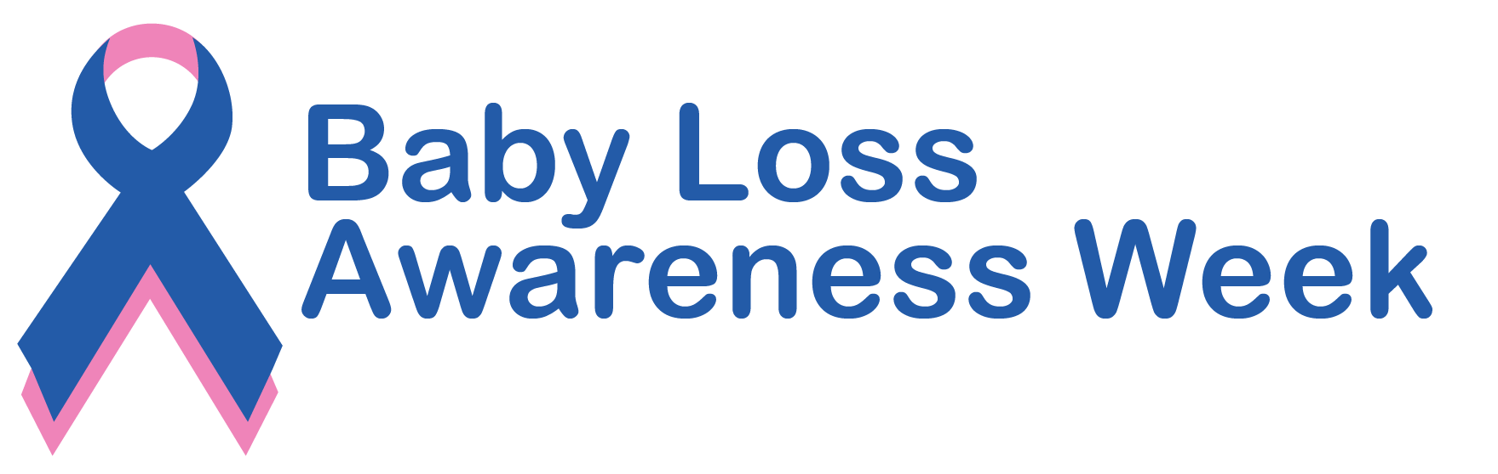

Baby loss awareness week – 9-15 October

REMBERANCE SUNDAY AND ARMISTACE DAY – NOV 10TH & 11TH

Remembering the service and sacrifice of all those that have defended our freedoms and to commemorate the end of hostilities of World War 1.



Travel Vaccines

We are now offering NHS travel vaccines at the practice. To find out further information and to see if you are eligible, please contact reception and request a travel vaccine questionnaire form.

A questionnaire will be sent across to you to complete and return to us. A nurse will then review this form and an appointment will be made dependent on the review.

**Please contact the practice at least 12 weeks in advance before your travel date to start this process**

Haslingden Healthcare are now offering a service for all patients to send directly Non-Medical Queries and Admin Requests using the link below, which includes sicknotes, letters and updates regarding test results.

You can access this service using the link below.

[**https://florey.accurx.com/p/P81099**](https://florey.accurx.com/p/P81099)

**You can also access this service using the NHS App.**

**For further information please speak to the reception team.**

*Patient Non Medical Queries -*

*GetUBetter MSK App*

Do you have a joint or muscle problem?

Please use the FREE NHS GetUBetter app designed and written by your local clinicians here in East Lancashire.

It offers local tips, advice and exercises tailored to you and your stage of recovery.

* Instant access
* Easy to use
* Safe and effective

Your healthcare professionals cannot be with you 24/7, but GetUBetter can…

Download the app here -   [**https://app.getubetter.com/request-access/1/571d3a9420bfd9219f65b643d0003bf4**](https://app.getubetter.com/request-access/1/571d3a9420bfd9219f65b643d0003bf4)

***STOPTOBER!***

**This October join the 2.5 million people who’ve been inspired by Stoptober. Even if it’s your first time or you’ve tried before, Stoptober gives you the perfect opportunity to quit smoking.**

**Stay smoke-free for 28 days, and you’re 5 times more likely to quit for good. With the right support, quitting is easier than you think 😊**



A week where transgender people and their allies take action to bring attention to the trans community by educating the public about who transgender people are, sharing stories and experiences, and advancing advocacy around issues of prejudice, discrimination, and violence that affect the transgender community. 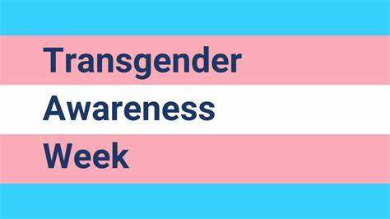

***TRANS AWARENESS WEEK – 13-19 Nov***

***ask the experts >>>***

MOVEMBER

**Men’s Health Awareness Month**

Responsible for thousands of moustaches on men’s faces. Aims to raise vital funds and awareness for all things related to men’s health including mental health, suicide, prostate cancer and testicular cancer.



SMOKING CESSATION

Smoking can lead to strokes, cancer, heart and lung disease. We strongly advise quitting. The best way to stop is with a combination of medication and specialist support.

*You can try the NHS Quit Smoking app, or for more information visit:* [*www.nhs.uk/smokefree*](http://www.nhs.uk/smokefree)



**It is officially Autumn!** Darker nights and colder days are nearly here.

Please remember flu season is upon us and at this time of year coughs and colds are on the rise. Please make sure to stay protected and wash your hands!

***The colder days are slowly approaching…***

Haslingden Healthcare is now participating in clinical trials.

Some patients may be contacted and receive a message alert about these clinical trials requesting you to join in.

If you are interested in the clinical trial then follow the instructions in the message you receive, please do not contact reception about this.

**No personal or medical information will be released without your consent.**





Clinical Trials

Prescriptions

Just a gentle reminder to patients that our prescription phone line is open from 9.00am-12.00pm.

Alternatively, you can order prescriptions through the NHS app, email or pop into reception.

**Stay up to date:**

Facebook – Haslingden Healthcare Ltd

Email – [mackenzie.reception@nhs.net](mailto:mackenzie.reception@nhs.net)

Number – 01706 335390

Would you like to join our PATIENT PARTICIPATION GROUP?

We are looking for enthusiastic, dedicated patients for their views on upcoming changes and to help shape the delivery of services. Some questions that could be raised are below…

* How long do I have to wait for a GP appointment?
* How can I access mental health services?
* I just want to check my blood test results, can I do this without speaking to a healthcare professional?
* Why do the receptionists need to know what my appointment is for?

For more information please contact reception:

01706 335590 or mackenzie.reception@nhs.net

*Finding An Agent That’s Right For You*