***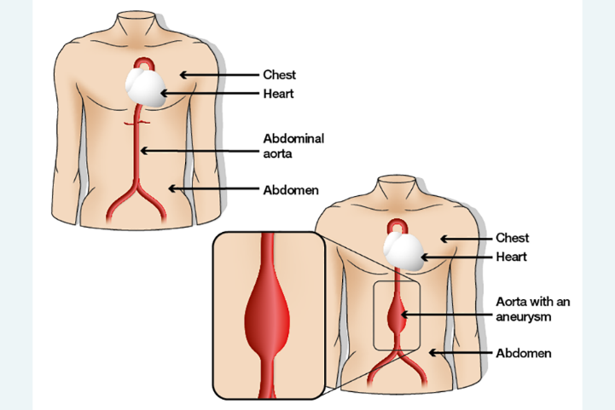*Abdominal Aortic Aneurysm Screening  
A national screening programme for men in the UK aged 65 and over**

**What is an Abdominal Aortic Aneurysm (AAA)?**An AAA is a swelling in the aorta (the main blood vessel in the body) as it becomes weaker with age. Around **1 in 92 men** in the UK aged 65+ have an AAA, and they are 6 times more common in men than women.If an AAA gets too large it can burst, which is likely to be fatal.

**How can screening help?**An AAA has no symptoms, so screening can detect one early,   
before it becomes dangerous. If one is found, it can then be monitored and treated.

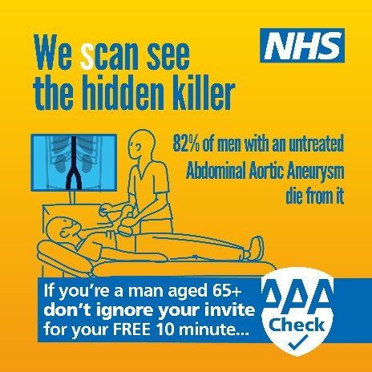**Who is screening for?**Anyone registered as male will automatically be invited during the year they turn 65.   
Men over 65 who have never been screened can book an appointment directly with the screening service. Men under 65 and women who have a family history of AAA can also be referred for screening by their GP.

**What happens during the appointment?**An ultrasound, which is safe, quick, and pain-free. Results will be given on the day. Most men will not have an AAA, and will not need to be screened again. Small and medium AAA’s will be regularly monitored with screenings, and men with a large AAA will be referred to a specialist to discuss treatment options.

**Screening saves lives!**

**Your local screening team:**

**Lancashire and South Cumbria AAA Screening Services - 0191 445 8747**

To find out more, including information for transgender and non-binary people, visit [www.gatesheadhealth.nhs.uk/services/aaa/](http://www.gatesheadhealth.nhs.uk/services/aaa/) or scan the code below: