

***in this issue JUNE 2024 >>>***

Issue

**South Asian Heritage Month**

**18 July -17August**

Aims to raise the profile and contribution of British South Asian history in the UK.



Led by the Men’s health forum to raise awareness of preventable health issues and encourage men and boys to seek professional advice for health-related problems.

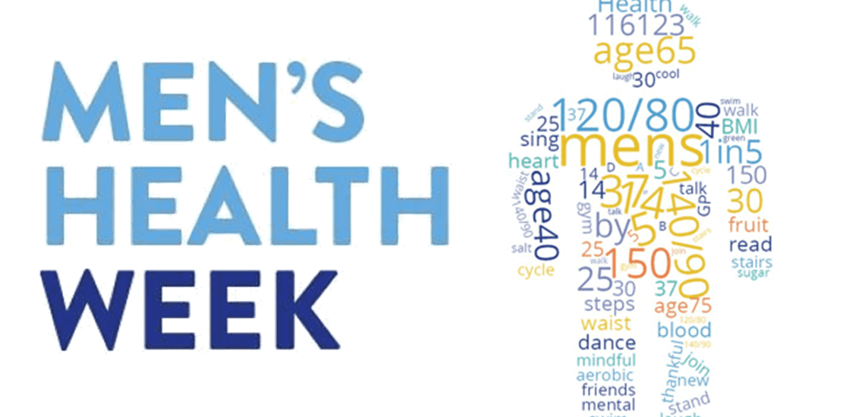

***Men’s health week***

***12-18th June 2024***



Eid Ul Adha this year will begin on the evening of Sunday 16th June and end on the evening of Thursday 20th June.

This is one of the most important festivals in the Muslim calendar.

**We would like to wish our fellow Muslim community a happy Eid! :)**

* *Alcohol awareness week*
* *Cycle to work day*
* *Men’s health week*
* *South Asian Heritage month*
* *The enhanced access service*
* *Travel vaccines*
* *Covid vaccine update*

***Eid Ul Adha 2024***

* *Eid Ul Adha*
* *Learning disability week*
* *New staff*

And MORE…

The Enhanced Access Service

The Enhanced Access Service in Rossendale is held at Rossendale Health Centre (Inside Ilex View Practice) as well as Bacup Health Centre (Inside Irwell Medical Practice)

The service is held at Rossendale Health Centre, 17:00pm – 20:45pm on Tuesdays, Wednesdays, Fridays and Saturdays 9-2pm. The service is held at Bacup Health Centre, 17:00pm – 20:45pm on Mondays and Thursdays. Appointments within this service are both Face to Face and Remote (Telephone/Video Call).

These appointments can be with either a GP, ANP, Practice Nurse or Health Care Assistant. These clinicians have access to your GP Practice record, to enable them to see all results, letters and consultations to enable a continuity of care during your appointment with the Enhanced Access Service.

Web: [**https://eastlancashirealliance.co.uk**](https://eastlancashirealliance.co.uk/)

Facebook: [**https://www.facebook.com/EastLancsAlliance/**](https://www.facebook.com/EastLancsAlliance/)

Email: [**Ela.servicefeedback@nhs.net**](mailto:Ela.servicefeedback@nhs.net)

**Haslingden Health Care NEWS**

**THE SUMMER ISSUE**



**Nurse Beth Dyson**

Hello, I'm Beth a new nurse at the practice! I have been a Nurse for over 10 years and a Practice Nurse for 2 years. I offer baby and adult immunisations, injections such as B12 and Zoladex, chronic disease management (mainly hypertension and asthma reviews), smear tests, bloods, blood pressure checks and lifestyle management.

**Nurse Georgina Symes**

Hello, I’m Georgina a new nurse at Haslingden Health Care! I have been a nurse for 7 years and a practice nurse for just over 1 year. I have worked as an AMU nurse and as a district nurse. I do baby and adult immunisations, smears, bloods, ECGs and injectable medications 😊

**Nurse Rachel Elven**

Hello I am Rachel I have been a qualified RGN for nearly 30 years and I have been a practice Nurse for 11 years. My scope of practice includes diabetes, advanced diabetic management / insulin initiation, respiratory, spirometry, cervical screening, IUD removal, childhood and adult immunisation, travel assessment and immunisation, FIT notes, and a Non Medical Prescriber prescribing within my competence and remit. I am developing competence in Lipid and BP management at present with support from Claire.

When I’m not in work I practice some of the things I preach - self care, exercise and I love a paddleboard session.

*Staff News!*



Travel Vaccines

We are now offering NHS travel vaccines at the practice. To find out further information and to see if you are eligible, please contact reception and request a travel vaccine questionnaire form.

A questionnaire will be sent across to you to complete and return to us. A nurse will then review this form and an appointment will be made dependent on the review.

**Please contact the practice at least 12 weeks in advance before your travel date to start this process**

Haslingden Healthcare are now offering a service for all patients to send directly Non-Medical Queries and Admin Requests using the link below, which includes sicknotes, letters and updates regarding test results.

You can access this service using the link below.

[**https://florey.accurx.com/p/P81099**](https://florey.accurx.com/p/P81099)

**You can also access this service using the NHS App.**

**For further information please speak to the reception team.**

Cycle to Work Day - 1st August 2024

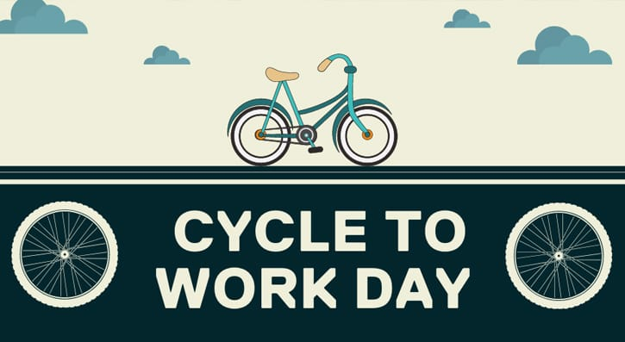

During this week, communities and organisations come together to provide support and education about alcohol use and misuse. The theme this year is ‘Understanding alcohol harm’ and promoting change.



Alcohol Awareness Week

1-7th July

*Patient Non Medical Queries -*

***ask the experts >>>***

The practice will be closed on the following date:

Monday 26th August - Summer Bank Holiday

For urgent requests please contact NHS 111. In an emergency dial 999.

Learning Disability Week

**19th-25th June 2024**

This week aims to educate, spread awareness and increase understanding of learning disabilities. The theme for this year’s Learning Disability week is ‘Do you see me?’ which is about challenging the barriers people with a learning disability face.



SMOKING CESSATION

Smoking can lead to strokes, cancer, heart and lung disease. We strongly advise quitting. The best way to stop is with a combination of medication and specialist support.

*You can try the NHS Quit Smoking app, or for more information visit:* [*www.nhs.uk/smokefree*](http://www.nhs.uk/smokefree)



*Bank Holiday Closures…*

COVID VACCINES

It has now come to the end of our covid spring boosters…

Our next batch of boosters will be offered in Autumn. You will receive an invite for this if you are eligible.

You can get your covid vaccine done at your local chemist or by ringing 119.

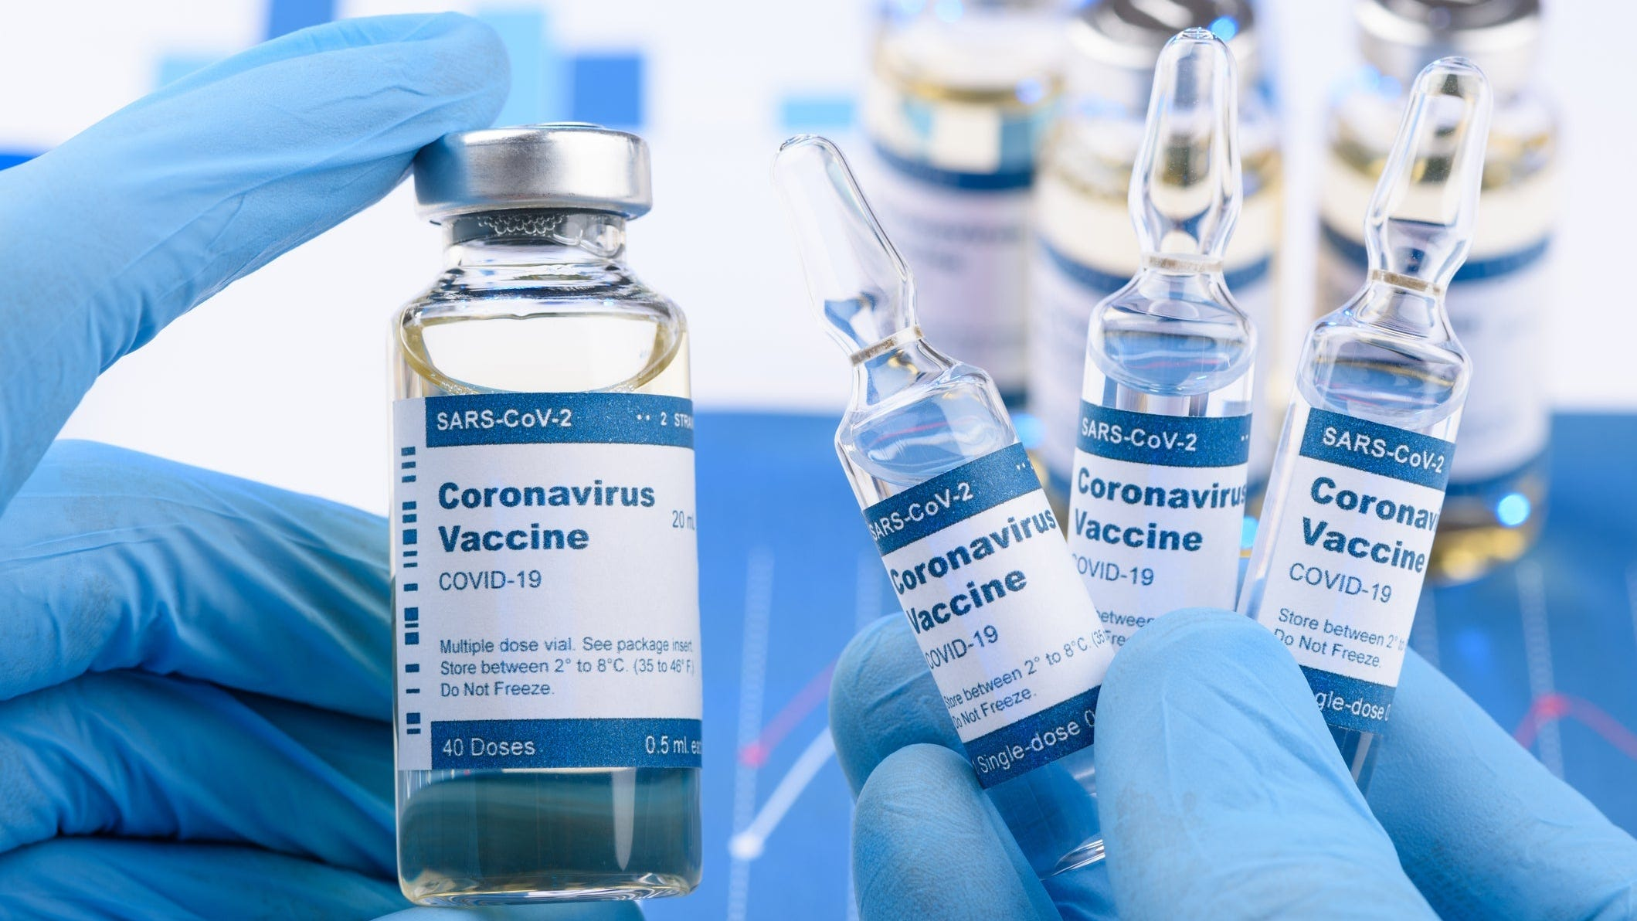

*GetUBetter MSK App*

Do you have a joint or muscle problem?

Please use the FREE NHS GetUBetter app designed and written by your local clinicians here in East Lancashire.

It offers local tips, advice and exercises tailored to you and your stage of recovery.

* Instant access
* Easy to use
* Safe and effective

Your healthcare professionals cannot be with you 24/7, but GetUBetter can…

Download the app here -   [**https://app.getubetter.com/request-access/1/571d3a9420bfd9219f65b643d0003bf4**](https://app.getubetter.com/request-access/1/571d3a9420bfd9219f65b643d0003bf4)

**It is officially Summer!** Lighter nights and warmer days are upon us. Please make sure to use sun protection.

Hay fever season is now here. Airborne grass pollens are at their peak in Summer, please make sure to stay protected.

***The hotter days are coming…***

Haslingden Healthcare is now participating in clinical trials.

Some patients may be contacted and receive a message alert about these clinical trials requesting you to join in.

If you are interested in the clinical trial then follow the instructions in the message you receive, please do not contact reception about this.

**No personal or medical information will be released without your consent.**





Clinical Trials

Prescriptions

Just a gentle reminder to patients that our prescription phone line is open from 9.00am-12.00pm.

Alternatively, you can order prescriptions through the NHS app, email or pop into reception.

**Stay up to date:**

Facebook – Haslingden Healthcare Ltd

Email – [mackenzie.reception@nhs.net](mailto:mackenzie.reception@nhs.net)

Number – 01706 335390

Would you like to join our PATIENT PARTICIPATION GROUP?

We are looking for enthusiastic, dedicated patients for their views on upcoming changes and to help shape the delivery of services. Some questions that could be raised are below…

* How long do I have to wait for a GP appointment?
* How can I access mental health services?
* I just want to check my blood test results, can I do this without speaking to a healthcare professional?
* Why do the receptionists need to know what my appointment is for?

For more information please contact reception:

01706 335590 or mackenzie.reception@nhs.net

*Finding An Agent That’s Right For You*